R. Reports Menu: 6. Revenue Report

Table of Contents
Revenue Report 3
The “General” tab 3
The “Accounts” tab 5
The “Export Options” tab 7
The “Period” tab 8

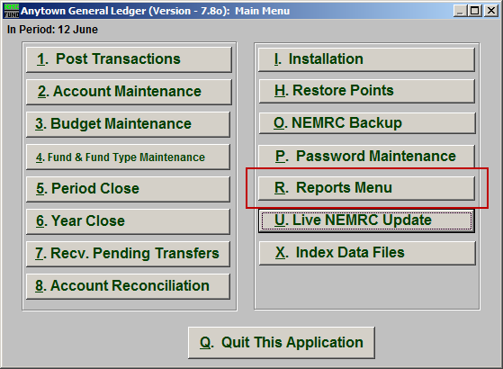
Click on “R. Reports Menu” from the Main Menu and the following window will appear:

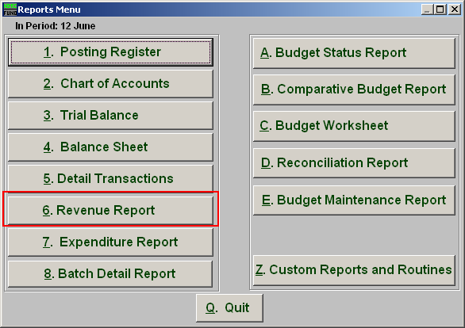
Click on “6. Revenue Report” from the Reports Menu and the following window will appear:

Revenue Report

The “General” tab

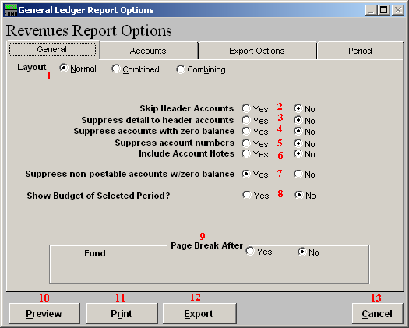

- Layout: Normal: Reports each fund separately. Combined: Reports all funds of the same type on the same page. Combining: Reports all types in totals on the same page.

- Skip Header Accounts: Header accounts are defined by incomplete account numbers. The system determines a sub-total on all accounts that match what has been defined in the header account. Selecting “Yes” removes the sub-totals.

- Suppress detail to header accounts: Selecting “Yes” will cause the system to report on header accounts defined and all accounts without header accounts defined.

- Suppress accounts with zero balance: You can choose to remove from reporting an account when it has a value of zero in both last year and this year for budget, actual and encumbrance.

- Suppress account numbers: You can choose to remove the General Ledger account number from reporting so that only the account description is shown on the report.
- Include Account Notes: Choose “Yes” to have this report include Account Notes that can be entered during Account Maintenance.

- Suppress non-postable accounts w/zero balance: You can have the system remove from reporting inactive accounts that have zero like in item 4. This option stops the inactive accounts from reporting. Item 4 would stop all zero balance accounts from reporting.

- Show Budget of Selected Period?: The options to show the budget figure for the selected period by dividing the total budget by twelve.

- Page Break After: Click to choose when a new page is started. The option for page breaks depends on the design for your chart of accounts.

- Preview: Click this button to preview. Refer to GENERAL PREVIEW for more information.

- Print: Click this button to print. Refer to GENERAL PRINTING for more information.

- Export: Click this button to save on this computer. Refer to GENERAL FILE for more information.

- Cancel: Click “Cancel” to cancel and return to the previous screen.

The “Accounts” tab

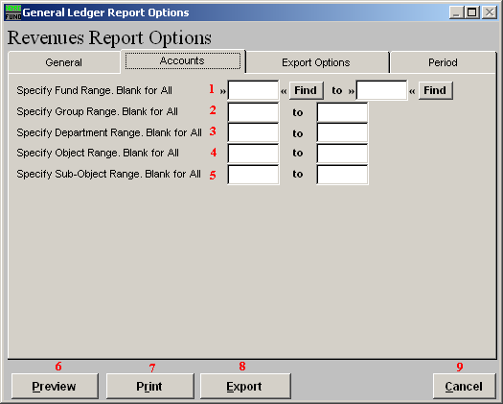

- Specify Fund Range: This option appears for all charts of accounts. Type in a beginning and ending fund number range to further restrict the reporting, if desired. Items 2 through 5 will vary according to the design and descriptions for your chart of accounts definitions.

- Specify Group Range: Enter a beginning and ending value range to further restrict the reporting, if desired.

- Specify Department Range: Enter a beginning and ending value range to further restrict the reporting, if desired.

- Specify Object Range: Enter a beginning and ending value range to further restrict the reporting, if desired.

- Specify Sub-Object Range: Enter a beginning and ending value range to further restrict the reporting, if desired.

- Preview: Click this button to preview. Refer to GENERAL PREVIEW for more information.

- Print: Click this button to print. Refer to GENERAL PRINTING for more information.

- Export: Click this button to save on this computer. Refer to GENERAL FILE for more information.

- Cancel: Click “Cancel” to cancel and return to the previous screen.

The “Export Options” tab

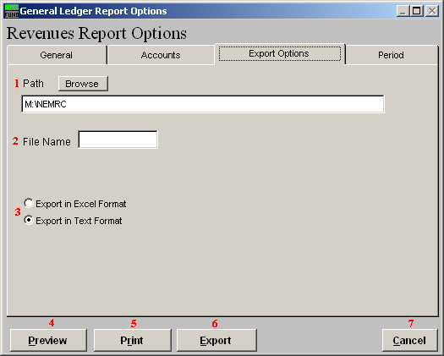

- Path: Type in the location of the folder you wish to save this report in when you export. You may click “Browse” to locate the folder.

- File Name: Type in the name that this report will be saved as.

- Export in Excel Format OR in Text Format: Click to choose whether this report will be exported in an Excel Format or in a Text Format.

- Preview: Click this button to preview. Refer to GENERAL PREVIEW for more information.

- Print: Click this button to print. Refer to GENERAL PRINTING for more information.

- Export: Click this button to save on this computer. Refer to GENERAL FILE for more information.

- Cancel: Click “Cancel” to cancel and return to the previous screen.

The “Period” tab

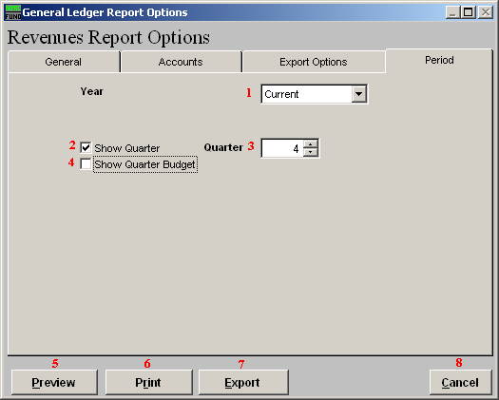
- Year: Select the year for reporting from the drop down list provided. This list includes as many years as possible stored in the system.

- Show Quarter: The option to report quarterly budgets will divide the total budget by four and calculate the expenses for the three month period chosen.

- Quarter: When item two or four is selected then the quarter to calculate has to be selected.

- Show Quarter Budget: A column can be added to the report that reflects the quarterly budget value.

- Preview: Click this button to preview. Refer to GENERAL PREVIEW for more information.

- Print: Click this button to print. Refer to GENERAL PRINTING for more information.

- Export: Click this button to save on this computer. Refer to GENERAL FILE for more information.

- Cancel: Click “Cancel” to cancel and return to the previous screen.

